**VEHICLE USER AUTHENTICATION USING OPENCV**

**A Major Project Report**

**Submitted in Partial fulfillment for the award of**

**Bachelor of Technology in Computer Science & Engineering**

Submitted to

**RAJIV GANDHI PROUDYOGIKI VISHWAVIDYALAYA**

**BHOPAL (M.P)**



**MAJOR PROJECT REPORT**

Submitted by

Abhishek Jain[0103CS171006]Bhola Prasad Chilhate[0103CS171046]

Krishna Yadav[0103CS171072] Ojasva Saxena [0103CS171091]

Under the supervision of

Prof. Nidhi Singh

Assistant Professor CSE Dept.



**Department of Computer Science & Engineering**

**Lakshmi Narain College of Technology, Bhopal (M.P.)**

**Session June 2021**

LAKSHMI NARAIN COLLEGE OF TECHNOLOGY, BHOPAL

**DEPARTMENT OF COMPUTER SCIENCE & ENGINEERING**



### CERTIFICATE

This is to certify that the work embodied in this project work entitled **“Vehicle User Authentication using OpenCV”** has been satisfactorily completed by the **Abhishek Jain** (0103CS171006), **Bhola Prasad Chilhate** (0103CS171046), **Krishna Yadav** (0103CS171072) and **Ojasva Saxena** (0103CS171091). It is a bonafide piece of work, carried out under the guidance in **Department of Computer Science & Engineering**, **Lakshmi Narain College of Technology, Bhopal** for the partial fulfillment of the **Bachelor of Technology** during the academic year 2020-2021.

**Guided By**

## (Prof. Nidhi Singh)

Assistant Professor CSE Dept.

**Approved By**

**(Dr. Bhupesh Gour)**

**Prof. & Head**

# Department of Computer Science & Engineering



LAKSHMI NARAIN COLLEGE OF TECHNOLOGY, BHOPAL

**DEPARTMENT OF COMPUTER SCIENCE & ENGINEERING**

**Acknowledgement**

We express our deep sense of gratitude to Prof. Nidhi Singh (Guide) department of Computer Science & Engineering L.N.C.T., Bhopal. Whose kindness valuable guidance and timely help encouraged me to complete this project.

A special thank goes to Dr. Bhupesh Gour (HOD) who helped me in completing this project work. He exchanged his interesting ideas & thoughts which made this project work successful.

We would also thank our institution and all the faculty members without whom this project work would have been a distant reality.

**Signature**

Abhishek Jain Bhola Prasad Chilhate

[0103CS171006] [0103CS171046]

Krishna Yadav Ojasva Saxena

[0103CS171072] [0103CS171091]

**INDEX**

|  |  |  |
| --- | --- | --- |
| **S.NO.** | **TOPICS** | **PAGES** |
|  | Introduction | 5 to 6 Pages |
|  | Literature Review | 5 to 6 Pages |
|  | Problem Statement & Objective | 1 to 2 Pages |
|  | Proposed design and methodology | 8 to 10 Pages |
|  | Implementation Details | 15-20 Pages |
|  | Result Snapshot | 10 to 12 Pages |
|  | Conclusion and Future Scope | 1 to 2 pages |
|  | References | 1 to 3 pages |
|  | Total Approx. 55-70 Pages | |

**CHAPTER 1**

**INTRODUCTION**

This research project uses the help of new modern breakthroughs in AI and ML to implement better solution to authenticate a user before riding a vehicle.

This project aims at developing a solution to authenticate or verify a user before using a vehicle.

The system would ask for user's driver's license to get details about the person, then it would also take video feed from the camera installed in front of driver's seat to verify the person, and finally decide whether to give access to the vehicle's controls or not.

The driver and his original driver's license are a must for this authentication system.

The working of the system would be displayed by developing an interactive and simplistic website, which would be using general directory system for storing user's data temporarily.

This website would be using OpenCV library for making rapid ML model to verify the identity of a user.

This project would be designed by using languages such as Python, HTML, CSS and JavaScript.

**CHAPTER 2**

**LITERATURE REVIEW**

We referred various online content and documentation on ML from various websites such as opencv.org, YouTube, etc.

We saw a potential to use the power of ML and OpenCV libraries to develop a meaningful project to authenticate the drivers.

We also visited some educational websites such as geeksforgeeks.com, medium.com, etc. to get general ideas to implement our problem domain by using websites as front-end.

We referred a YouTube channel called CodingEntrepreneurs for learning to implement OpenCV libraries in a project using Python.

We consistently visited various educational sites for solving small sub-problems in the problem domain.

**CHAPTER 3**

**PROBLEM STATEMENT & OBJECTIVE**

3.1 Problem Statement

3.1.1 Problem Statement

3.1.2 Problem Domain Description

The problem domain for this project is related to Road Safety and Security.

This project uses the ongoing modern technologies and tools into practice to develop a useful software or website for general public to embed in a vehicle for safety and security.

We see nowadays that some people illegally driving various vehicles, without owning a specific driver’s license for themselves.

This system will be helpful for general public by implementing an interface to verify the driver before giving him access to a vehicle. This system would give access to the drivers owning a verified driver’s license.

We will be developing a website for accepting driver’s license and video feed containing the driver’s face for verification. The website is expected to be interactive and simplistic.

The verification system will be developed by the use of specific machine learning algorithm by referring the OpenCV library.

3.1.3 Problem Analysis

We will be using the image in the license and images from the video feed to match together to verify the person in the video feed. For coding this process, we are required to import libraries such as numpy, pickles, OpenCV, etc. for storing data, objects and for training our ML model and for performing other functions.

Then we need to develop a website to serve as a front-end and it would require scripting languages such as HTML and CSS. Also, then we have to develop some Python scripts to process the inputs from user and authenticate the user, which will reflect back to the website.

3.2 Objective

3.2.1 Project Objective

Following are the major objectives of our project:

* Gathering all the information and the tools necessary for building this project.
* Designing a meaningful and simplistic website for efficient usage of the system.
* To design fairly accurate user verification system using OpenCV tools.
* Writing an optimized and robust code for the website design and the internal program.
* To develop our website and its processes as fast, efficient and robust as possible.
* Integrating the website and the internal program.
* Performing thorough testing of the project.

3.2.2 Scope of Project

* + We will build our machine learning model using python because it is very interactive and easy to code in case of developing ML models. For the major part we will be using OpenCV library and its tools for training our ML model. There are other various libraries available in python such as pickles, numpy, pandas, scipy, scikitlearn, etc. which are a great help in machine learning.
  + Also, we will be using HTML, CSS, and various technologies and some python scripts and libraries such as Flask to develop website and deploy our ML model to website.
  + Due to hardware limitations for building ML model, we will be using a relatively small dataset for our model which might not work much efficiently (due to small training set). Apart from hardware limitations, ML models never works fully perfect in every scenario, rather it may improve overtime.
  + For most of the time, OpenCV Machine Learning algorithms gives out fairly accurate predictions.

**CHAPTER 4**

**PROPOSED DESIGN AND METHODOLOGY**

Fig 5.1 shows the DFD for this project and Fig 5.2 shows the Use-Case diagram for the Project.

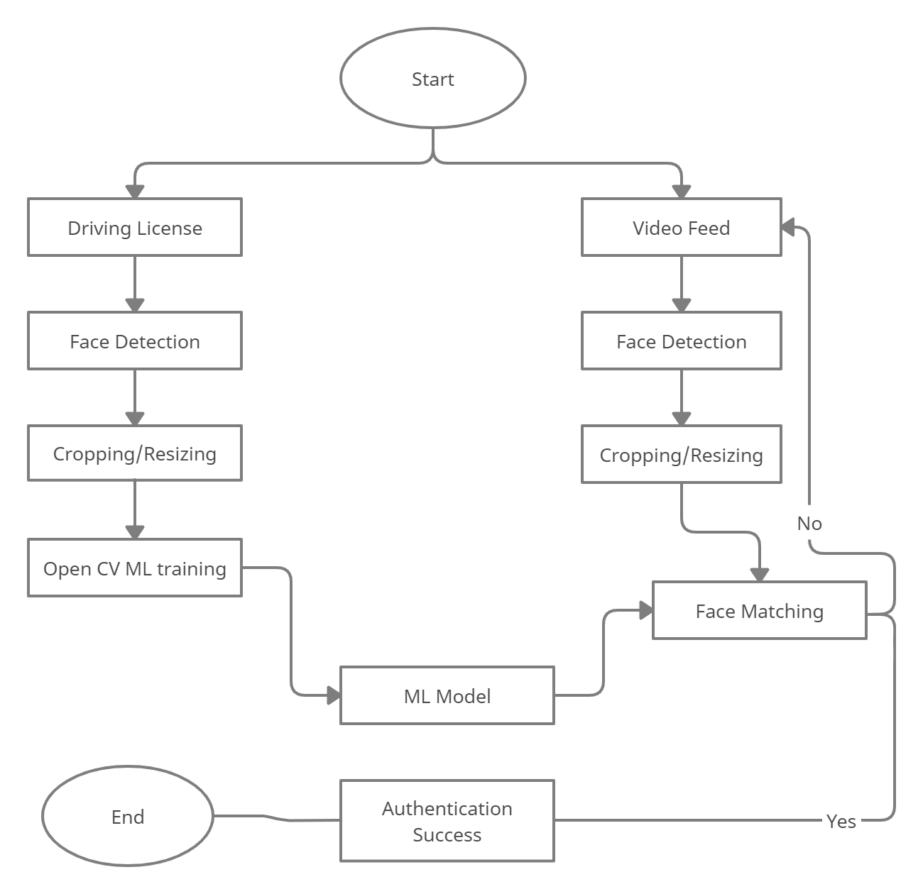

Fig 5.1 Data Flow Diagram of the project

Fig 5.1 shows the Data Flow Diagram in which mainly two inputs, license image and video feed are taken from user and further processing on the images such as face detection, cropping and resizing of images are performed in real-time. Then the processed images are taken for Model training and face matching, and the process repeats for a certain limit, if face does not match. Otherwise, if match is found, access is granted to the user and the process ends. If match is not found after enough iterations, user is denied to access the vehicle.

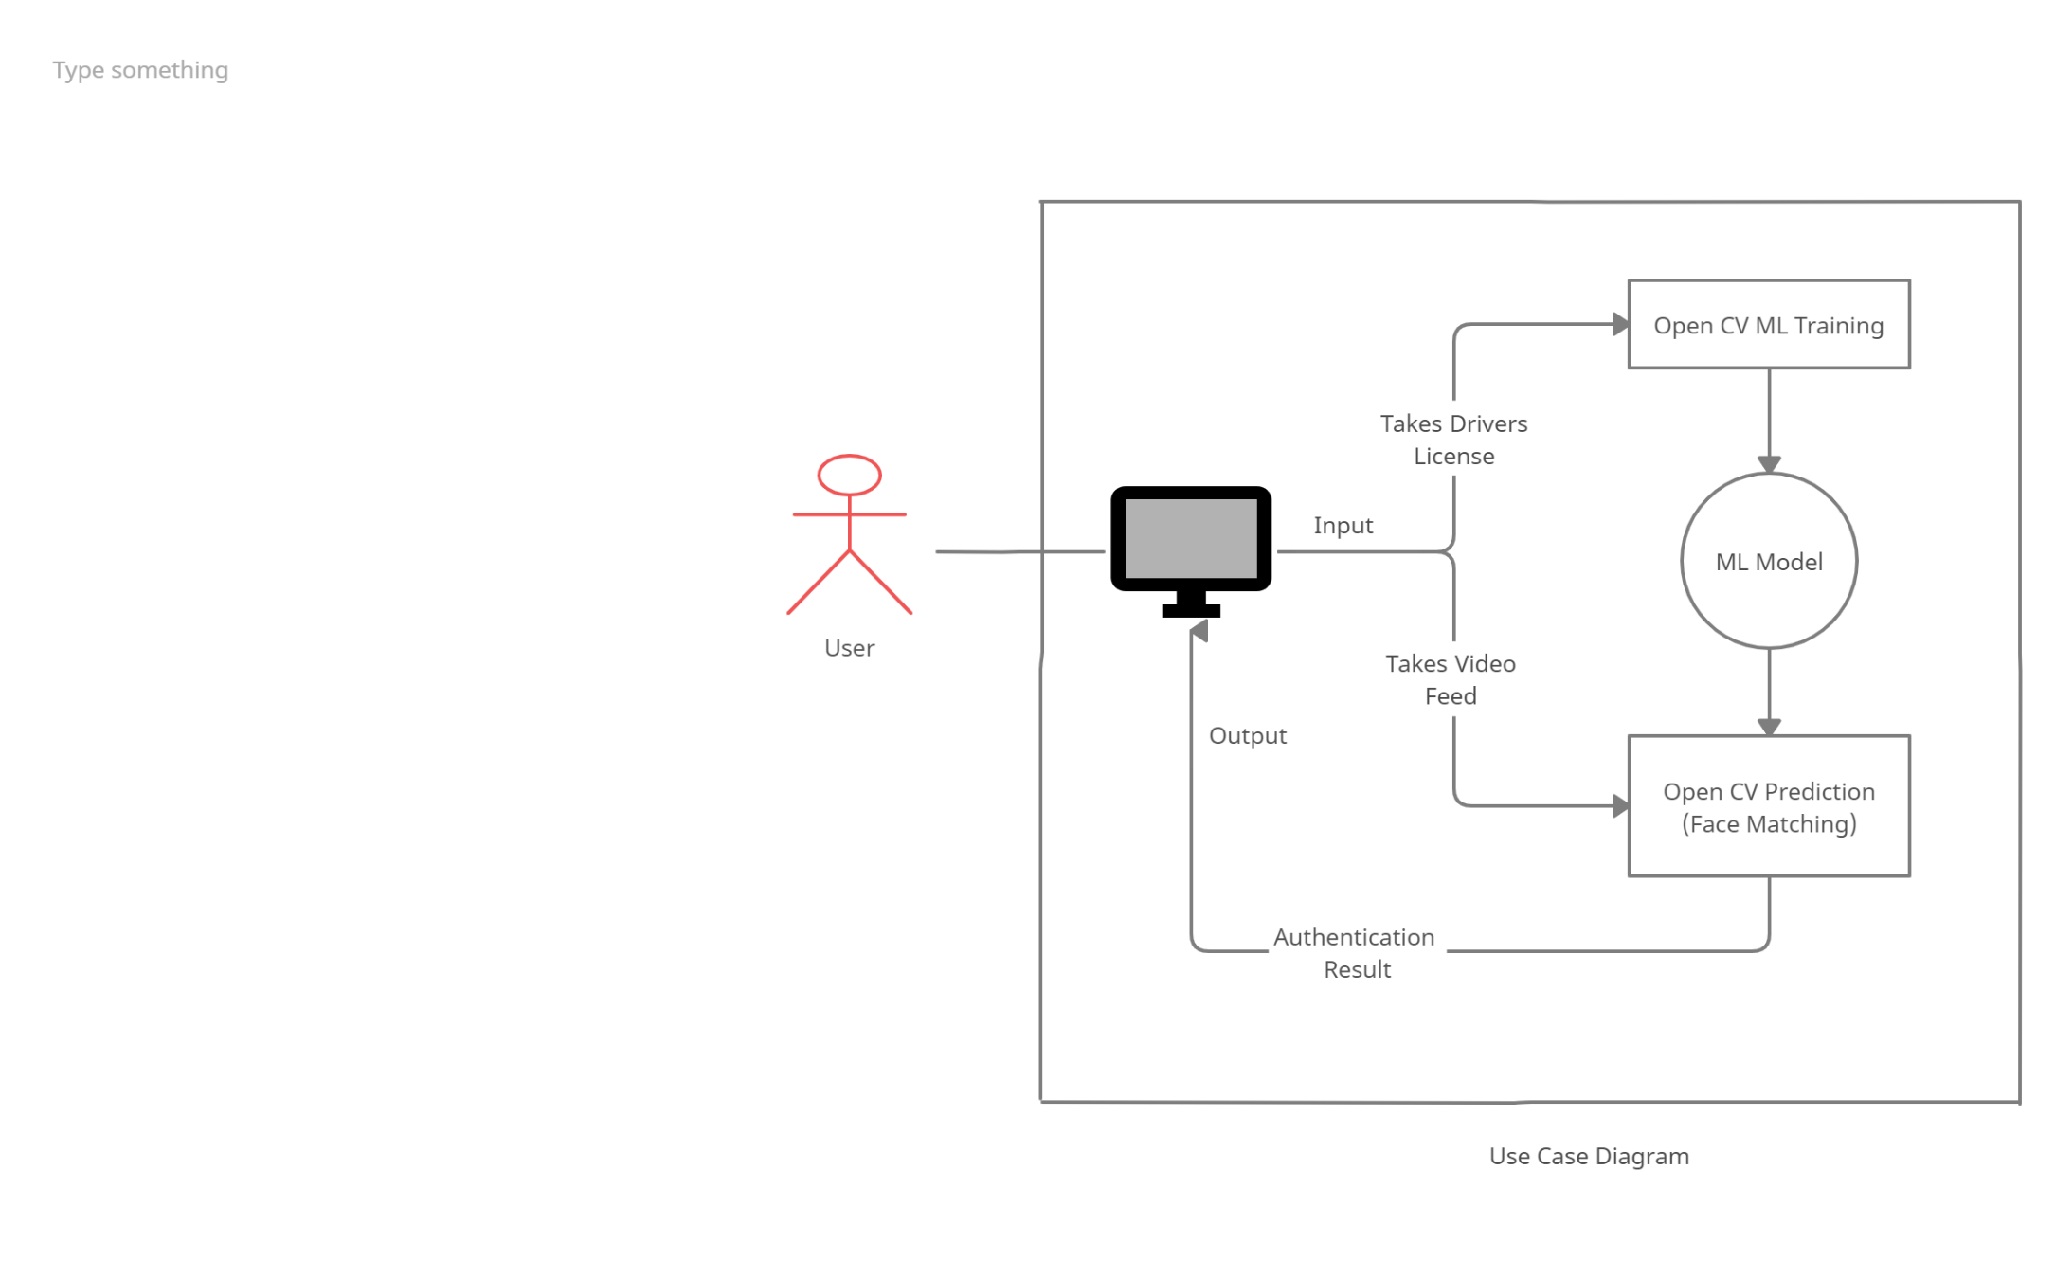

Fig 5.2 Use-Case diagram of the Project

Fig 5.2 shows the use-case diagram of the project, in which the user is asked his driving license first which is processed to train a model by using OpenCV library. Then the user is asked to provide his real-time video feed, which is processed by the machine and is further matched against the trained ML model. Using the results, the program decides whether to authenticate the user or not and displays out the result on the website for the user to see.

**CHAPTER 5**

**IMPLEMENTATION DETAILS**

4.1 Hardware Platform Environment

Following are the requirements for hardware platform environment of the project:

* A working PC or Laptop.
* A working Webcam.
* Processor: Any (Intel, AMD, etc.)
* GPU: Any (Nvidia, AMD, Intel, etc.)
* Memory: min. 1 GB RAM (2 GB recommended).
* Working internet connection (Recommended).

4.2 Software Platform Environment

Following are the requirements for hardware platform environment of the project:

* Operating System: Any Latest (Windows, Linux, etc.)
* Any latest Browser with JavaScript enabled. (Chrome, Firefox, etc.)
* Scripting languages such as HTML, CSS, Python 3, etc.
* Latest Python setup used with certain libraries installed.
* Libraries such as numpy, cv2(OpenCV), pickles, etc.
* Website development environment such as Notepad++ and Google Chrome.
* Development environment such as Anaconda and python 3.
* Web server deployment software (Apache, WAMP, XAMPP, etc.)

**CHAPTER 6**

**RESULT SNAPSHOT**

Start introduction

END OF INTRODUCTION

**CHAPTER 7**

**CONCLUSION AND FUTURE SCOPE**

7.1 Conclusion

Start here

7.2 Future Scope

Following key points can add up to the future scope of the project:

* We might embed our solution to Arduino or Raspberry Pi, so that we can test our system on actual vehicles or a simulated environment.
* We might also validate driver’s license using online government servers for better security.
* We might also add a functionality to allow only certain person to use vehicle, even if they have valid license, so that we can reduce Vehicle Theft.

We can improve our ML model’s accuracy by increasing development environment capabilities.

7.3 Project Limitations

This project might have following limitations:

* This project only provide solution through website and it does not provide any application for the user. So, it is limited to websites only for now.
* Face detection can be fooled by showing a photograph or similar faces.
* The dataset used in developing the model is relatively small which might affect the accuracy of the prediction of our project.
* Due to hardware limitations of the developing environment, the ML model is less reliable and less accurate.
* In practice, ML model are never said to be always accurate in predicting as compared to actual human being’s prediction.

**CHAPTER 8**

**REFERENCES**

* <https://docs.opencv.org/>
* <https://github.com/maddevsio/go-idmatch>
* <https://github.com/CatalystCode/faceanalysis>
* <https://github.com/domjhill/Python-FaceTemplateMatching>
* <https://www.youtube.com/PmZ29Vta7Vc>
* <https://www.google.com/>
* Websites like [www.javatpoint.com](http://www.javatpoint.com), [www.geeksforgeeks.com](http://www.geeksforgeeks.com), etc.